Sweet potato smoothie bowl

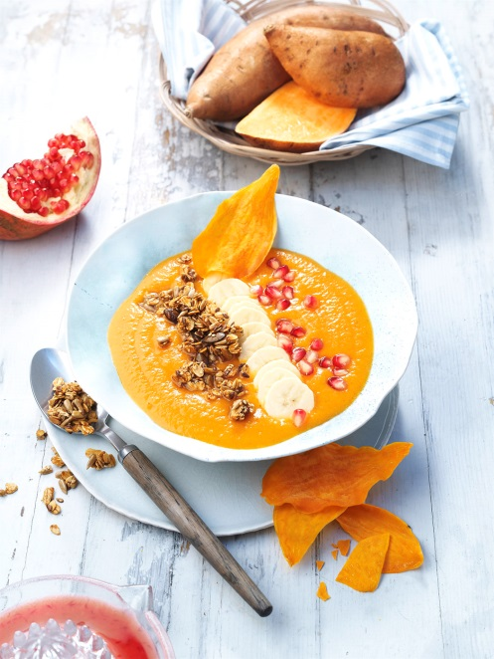
Ingredients for 4 smoothies à 200 ml:
500 g sweet potatoes from North Carolina

Crunch:
30 g 5-Kernel mix/ seed mixture (sunflower seeds, buckwheat, pumpkin seeds, sesame and flaxseed)
40 g oats
30 g honey
1 tsp salad oil

Smoothie/topping:
250 g fine sugar
6 blood oranges
1 lemon
2 bananas
Ras el hanout
Lemon juice
60 g pomegranate seeds

Preparation:

- Preheat oven to 180° C (upper and lower heat). Wrap sweet potatoes -except one- into aluminum foil and bake for 60-80 minutes. Take out of the oven, then take out the pulp with a spoon – 300g is needed.

- Mix the seeds with oats, honey and oil, then spread on a baking tray lined with baking paper. Roast in the oven until the mix becomes golden-brown. Take out and let cool.

- Put oven on 100° C. Peel the remaining sweet potatoes and slice very fine. Bring sugar and 250 ml water to a boil, let the slices steep inside for 30 minutes. Then let syrup drain (tip: you can use it to sweeten other dishes). Place the slices next to each other on a baking tray lined with baking paper and dry in the oven for about two hours. Turn the slices around after an hour.

- Squeeze blood oranges and lemons. Peel bananas, cut into slices and spill with some lemon juice. Blend orange juice and remaining lemon juice with half of the bananas and the cooked sweet potatoes and season with Ras El Hanout.

- Arrange the smoothie in bowls, then garnish with crunch, sweet potato chips and the remaining banana slices. Finally spread the pomegranate seeds over the top.

Nutrition facts per portion:
Energy: 420 kcal/ 1740 kJ
Protein: 7,5 g
Fat: 6 g
Carbohydrates: 78 g

