Grilled sweet potato salad
with spicy dressing, blue cheese & pecan nuts

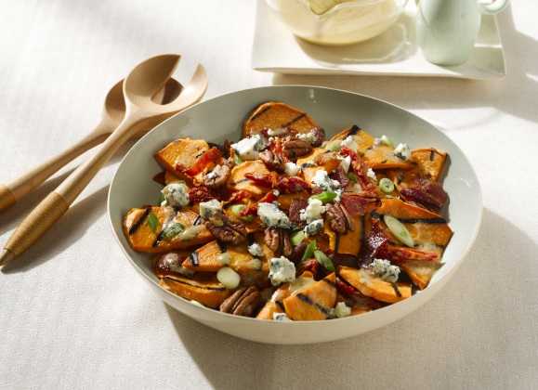
Ingredients (6 servings):

For the dressing
6 slices bacon
2 tablespoons raspberry vinegar
1 tbsp Dijon mustard
6 tbsp virgin olive oil
1 tbsp greaves lard
Sea salt
Freshly ground black pepper

For the sweet potato salad
1,2 kg sweet potatoes from North Carolina
3 tablespoons olive oil
60 g spring onions
50 g dried tomatoes
75 g blue cheese
40 g roasted pecan nuts
Sea salt
Freshly ground black pepper

- For the dressing: Preheat oven to 90 - 100°C. Fry the bacon in a pan until crispy, drain the excess fat and crumble the bacon. Mix vinegar and mustard in a bowl and slowly add olive oil and lard. Season to taste with salt and pepper. Keep warm in the oven.

- Peel sweet potatoes, cut them into thick slices and place them in a plastic bag with olive oil and sea salt. Mix well. The sweet potatoes must be completely covered with oil.

- Preparation on the grill: place slices on the grill rack and grill for 3 minutes on both sides. Remove from direct heat and grill for 20 - 30 minutes until soft and cooked. Remove from grill, cut into quarters and place in a bowl.

4. Alternatively preparation in the oven: preheat oven to 200°C. Fry salted sweet potatoes on a grid in the oven for about 30 minutes until soft and brown.

5. For the salad: add 2 tablespoons of the dressing to the sweet potatoes and mix. Cut the spring onions and dried tomatoes into small pieces and add them together with the bacon, crumbled cheese and pecans nuts. Cover with a little more dressing and season to taste. Serve immediately or after cooling.

