Asparagus with confected sweet potatoes, leek and lemon foam

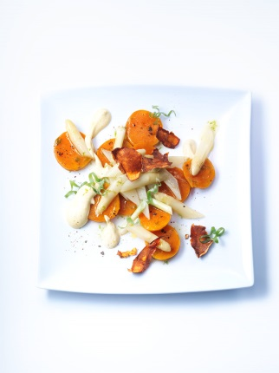
For the asparagus:
500 g peeled white asparagus
30g butter
120ml chicken stock
300g creme double
3 leeks (cut green of leek, slice white part in 3 cm pieces)
Salt, sugar, white pepper from the mill

Cut asparagus into halves, lengthwise. Slice halves in thirds and then cut in pieces, each 4 cm long. Sauté asparagus in butter, season them, add poultry broth and cook. Keep asparagus broth for further processing. Mix leek with asparagus and season it.

For the sweet potatoes:
2 sweet potatoes from North Carolina
Sea salt
Olive oil
Peel of lime
Piment d’Espelette

Season sweet potatoes with sea salt and drizzle with olive oil. Wrap in aluminum foil and cook in the oven at 160 °C for ca. 40 minutes. Peel and slice in evenly pieces and sauté in butter with lime peel and Piment d’Espelette.

Our Tip:
Dry cooked sweet potato peel in the oven at 80 °C overnight and roast it in a pan until it is crunchy. Afterwards season the chips with salt.

For the lemon foam:
2 whole eggs
2 egg yolks
120 ml olive oil
5g Dijon mustard
Sherry vinegar, salt, cayenne pepper, pinch of salt
Scoring of ½ lemon
Dash of lemon juice

1 siphon 0,5l
2 N20 capsules

Put all ingredients in a jar and froth it with a mixer until you have an emulsion that can be put in the siphon. Close siphon and put in 70 °C warm bath. Shake from time to time so that the egg does not clot.

Serving:
Spread asparagus, leek and sweet potato on the plate, drizzle with lime foam and scatter leek slices on top to finish the dish. Garnish plate with your sweet potato chips.

